Get Kindle books from OverDrive:
- Go to OverDrive.
- Find a book.
  - Click to search by title, author or topic.
  - Click Subjects or Collections to browse (first click if needed).
To see only Kindle books, select Kindle Book under the eBooks filter. This is on the left on full-sized screens. On devices it's near the top under Filters.
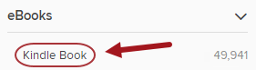
Alternatively, go to the Advanced Search. Under Formats choose Kindle Book, make other desired selections and then Search.
- Tap Borrow if available. If the item has a wait list, you can place a hold to get in line. If prompted, sign in using your Library Card number and password.
Tip: You can have 10 checkouts and 7 holds in OverDrive at a time.

- Use the drop-down menu to select your checkout period. Tap Borrow.
- Next to the book, choose Read now with Kindle.
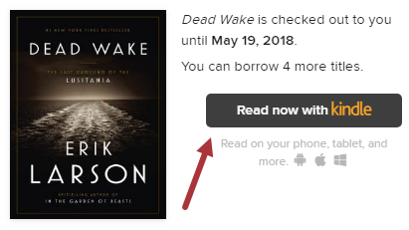
Tip: You can get the Kindle book at a later time by clicking in the top right.

- Amazon will load in a new tab or window. Find Get library book on the right. If you are already signed in, confirm the device to which you want the book delivered with the drop-down menu and then click Get library book.
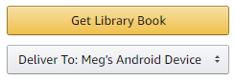
If you are not signed in, click Get library book and sign into your Amazon account. You will then choose your device and click Continue.
- Your Kindle book will be delivered the next time your device syncs.
If you have a Kindle tablet (Kindle Fire / HD / HDX), you can use the OverDrive app to check out Kindle books plus EPUB format eBooks and MP3 Audiobooks, which you can listen to through the app.

