How to place a hold on books
- Go to our website: https://rockwellfalls.sals.edu/
- Click on Card Catalog

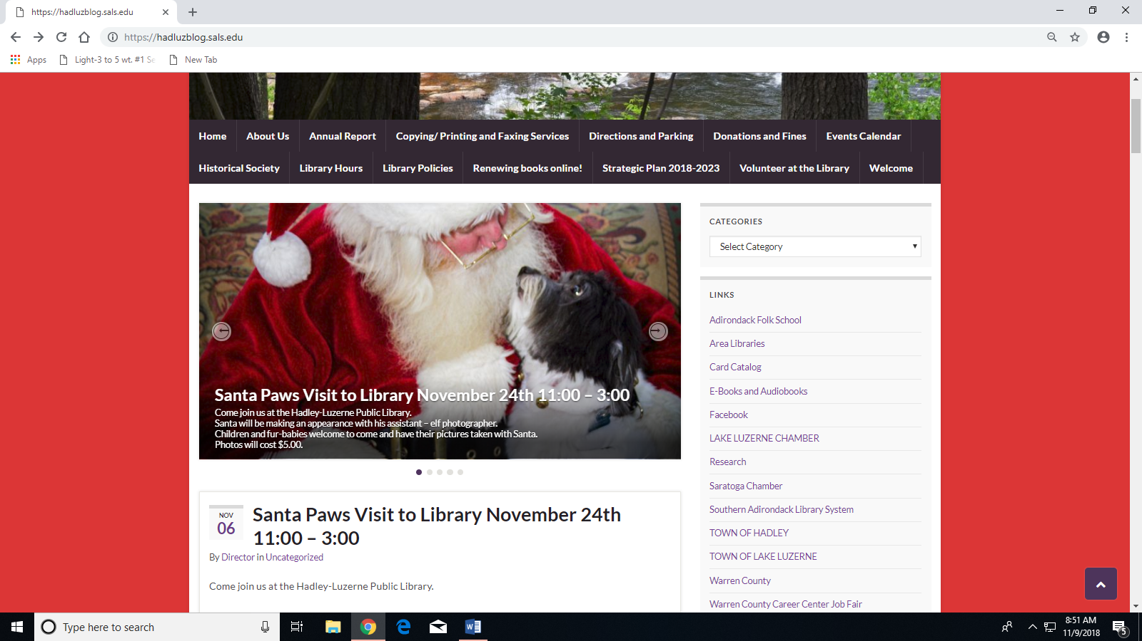

- Go to New Search

You can search by keyword in many different ways. If you are looking for a particular book by an author it is best to search by author.

Example:
I want to find a book by Dick Francis, so I type Dick Francis into the search bar.
- Type author’s last name first and separate by comma

Now we come up with a list of books by this author.
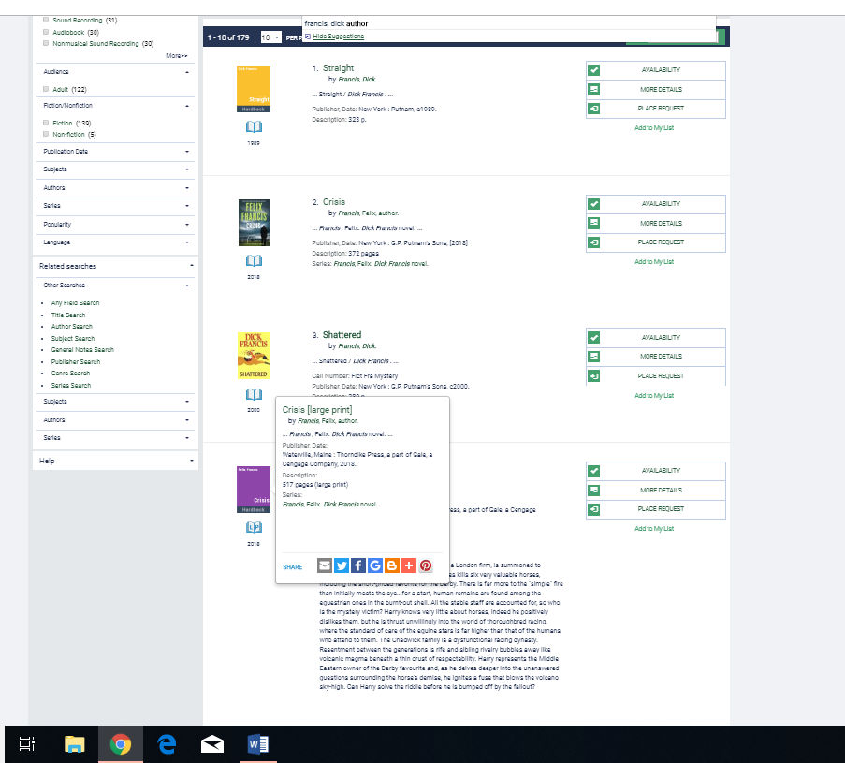
- If there are many books by this author scroll to the bottom of the page and tab to the next page to continue looking. When you have found the book you want click on Place Request
- Now enter your library card barcode and password and click Login.

- Next you will arrive at a screen that asks you were to pick the book up at.
8. Then simply submit request.

If we don’t have a book in our library we can get one from our Inter-Library Loan within 2 working days. We will contact you when the book arrives and will hold it for up to 7 days for you to collect.

